37.62: a) From Eq. (37.37),
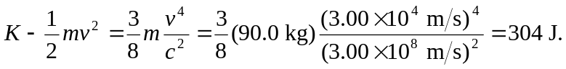
b) 